**Science Inquiry Skills**

Quantitative Data:

Numerical data; specific amount

Qualitative Data:

Non-numerical data; descriptive data

Model:

Is an aid to understanding. But a model is not the same as the thing itself. A model is a model. The thing to which a model refers is the thing to which it refers.

**Fundamental Units**

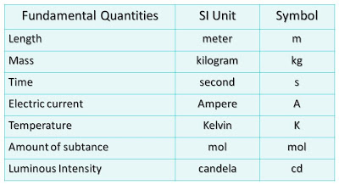

**Prefixes:**

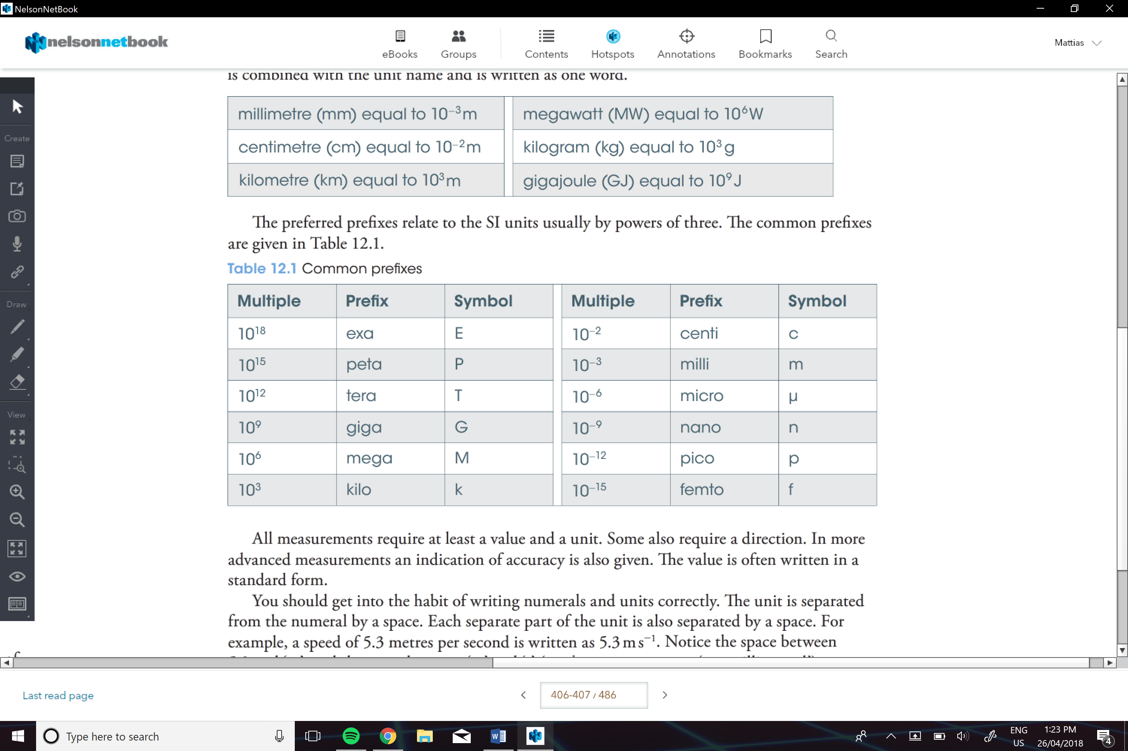



**Accuracy:**

refers to the closeness of a measured value to a standard or known value

**Precision:**

The limitations of the tool

**Uncertainty:**

Estimate of the range of values within which the ‘true value’ of a measurement or derived quantity lies

**True Value:**

The exact value of a measurand; the ‘true value’ is an ideal that can never be known with certainty

**Relative an Percentage Uncertainty:**

Relative and percentage uncertainties are usually given to 2 significant figures. They have no units because they are the ratio of the absolute uncertainty in the measurement.

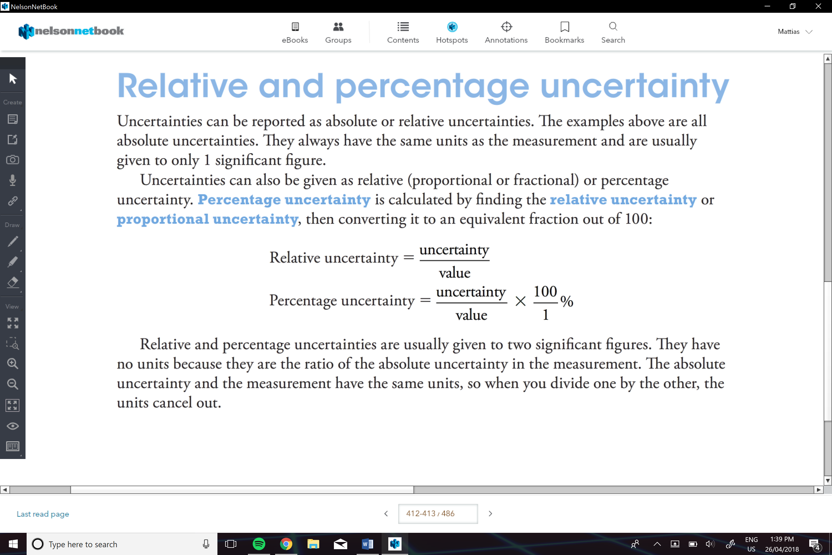

**Proportional Error:**

It is the difference between a measurement and an accepted value, expressed as a fraction of the accepted value.

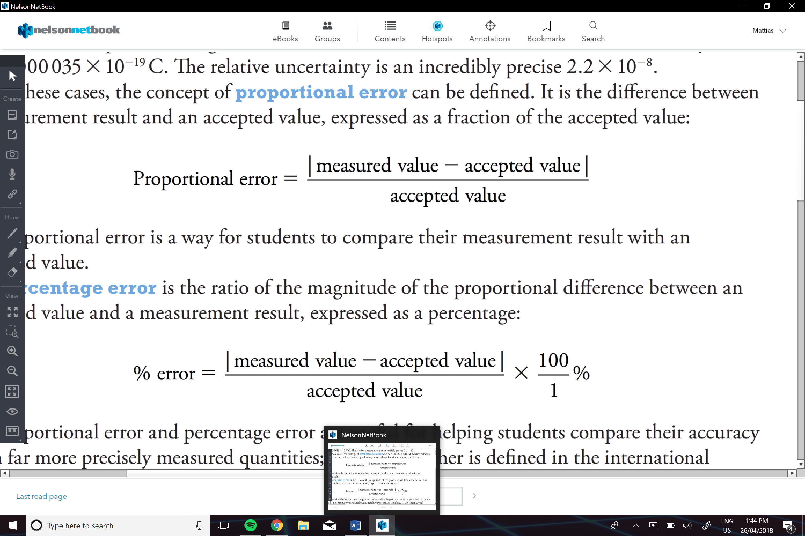

**Percentage Error:**

Is the ratio of the magnitude of the proportional difference between an accepted value and a measurement result, expressed as a percentage.



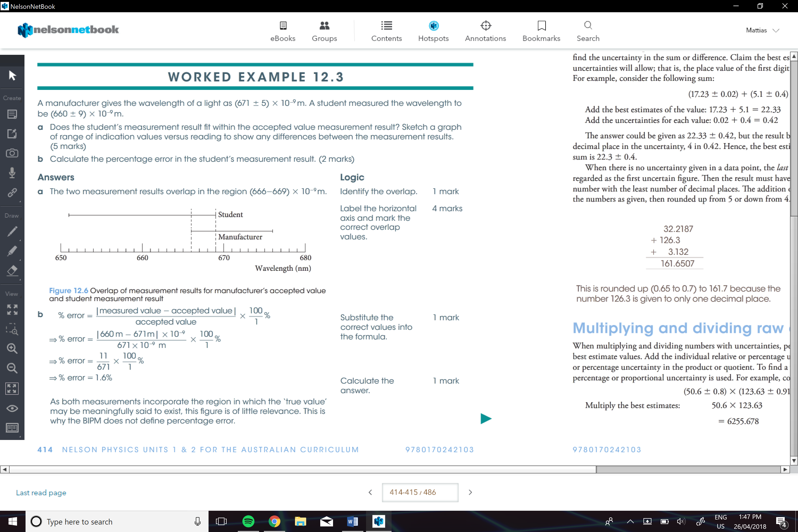Example:

**Adding and Subtracting Uncertainties:**

1. Add or subtract the 2 values
2. Add the individual uncertainties to fin the uncertainty in the sum or difference
3. Claim the best estimate only as far as the sum of uncertainties will allow; that I, the place value of the first digit of the sum of the uncertainties.

**Rule: (A ± ∆A) - (B ± ∆B) = (A - B) ± (∆A + ∆B) (A ± ∆A) + (B ± ∆B) = (A + B) ± (∆A + ∆B)**

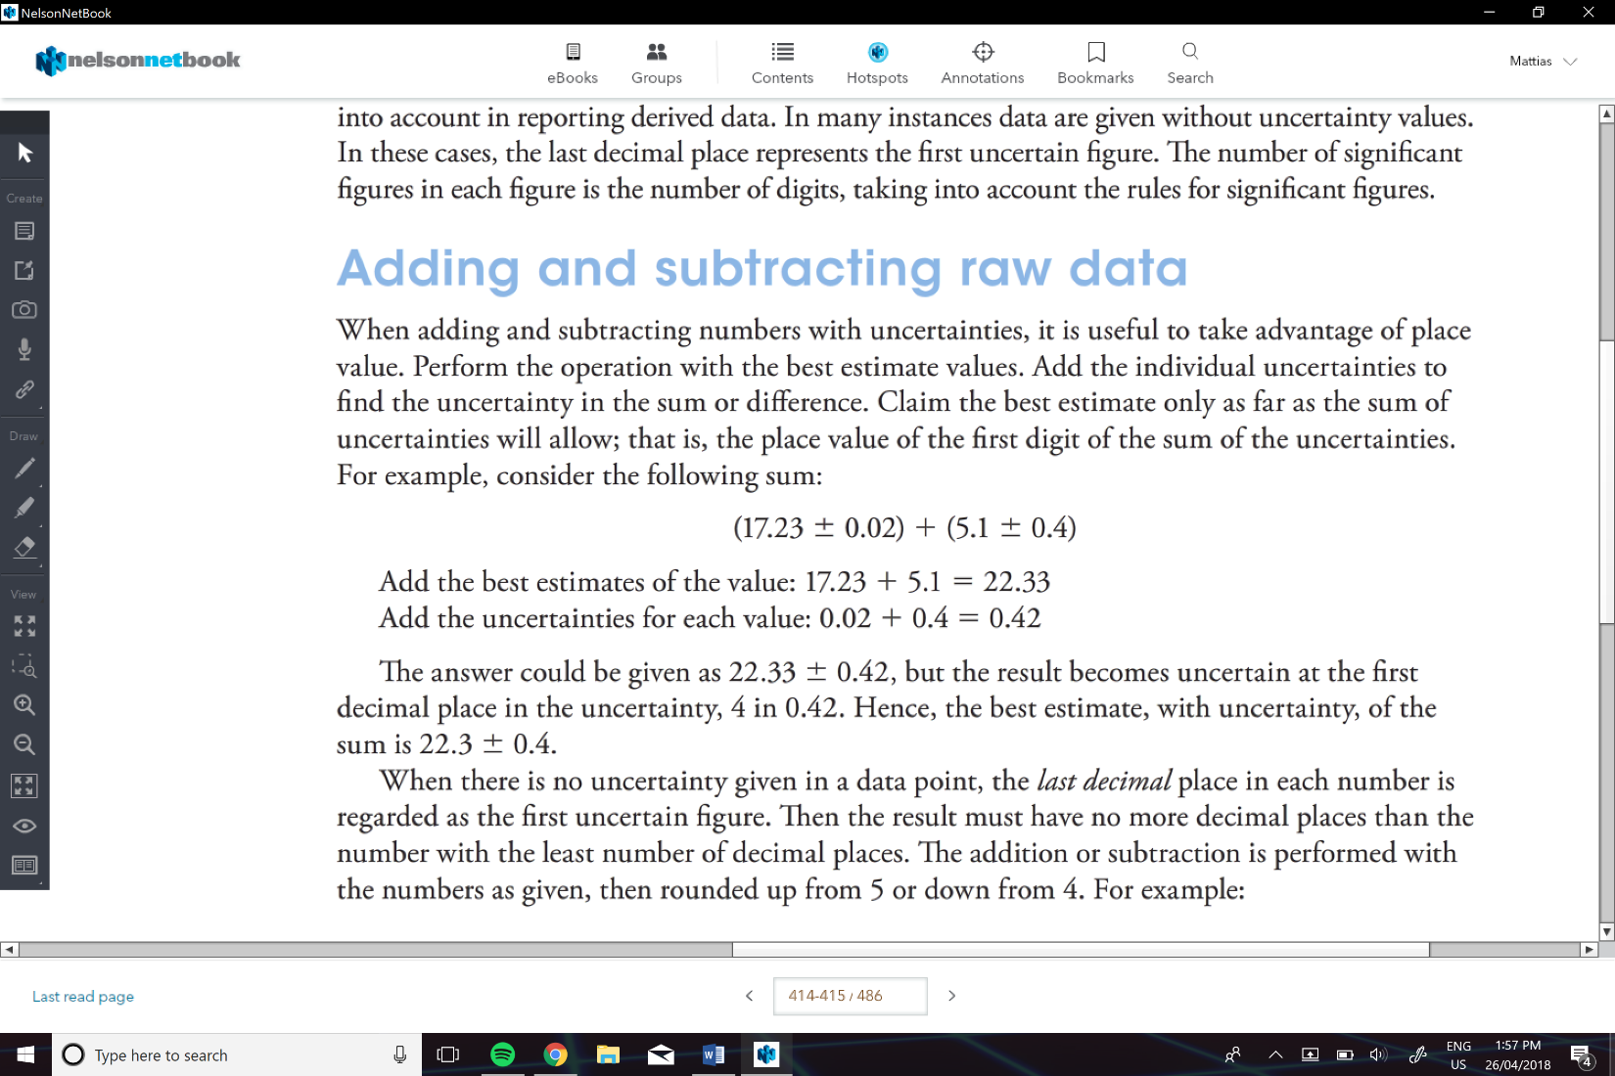e.g.

**-When there is no uncertainty given in a data point**

1. The last decimal place in each number is regarded as the first uncertain figure
2. Then the result must have no decimal places than the number with the least decimal places
3. The addition or subtraction is performed with the numbers as given
4. 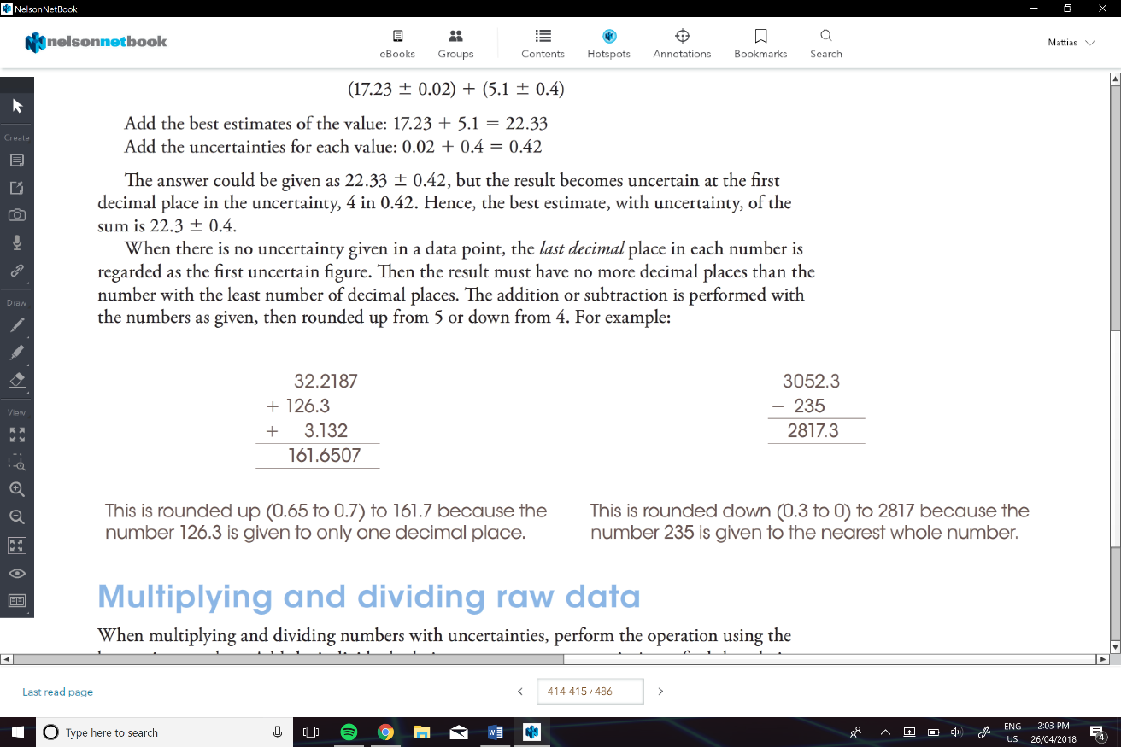Then rounded up from 5 or down from 4

e.g.

**Multiplying an Subtracting Raw Data:**

1. Perform using the best estimate values
2. Add the individual relative or percentage uncertainties to find the relative or percentage uncertainty in the product or quotient
3. To find the value for the uncertainty, the percentage or proportional uncertainty is used.

**Rule: (A ± εA) / (B ± εB)**

**= (A / B) ± (εA + εB) (A ± εA) x (B ± εB)**

**= (A x B) ± (εA + εB)**

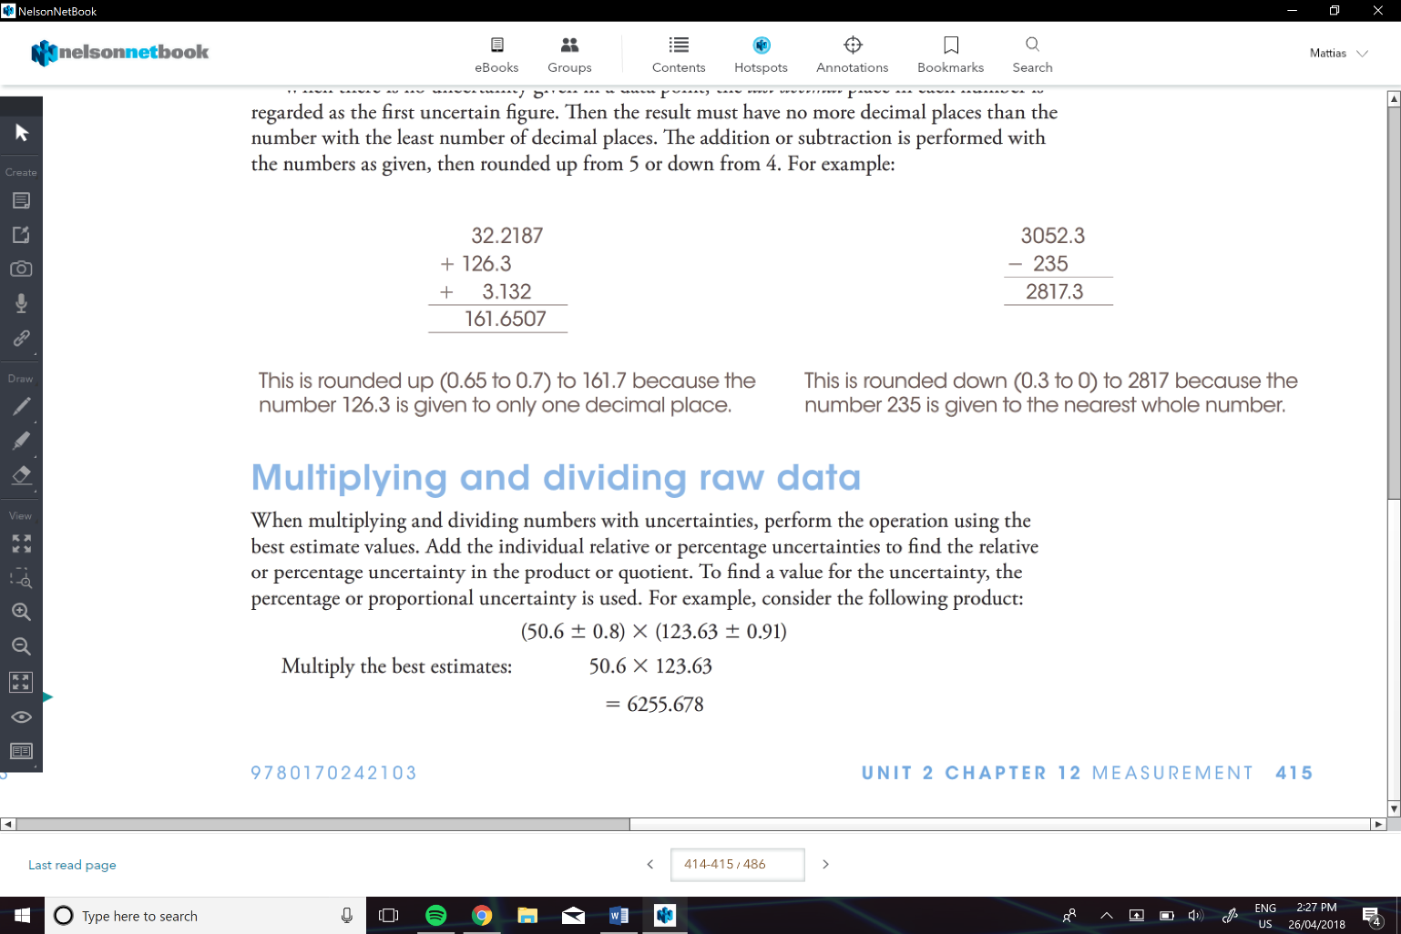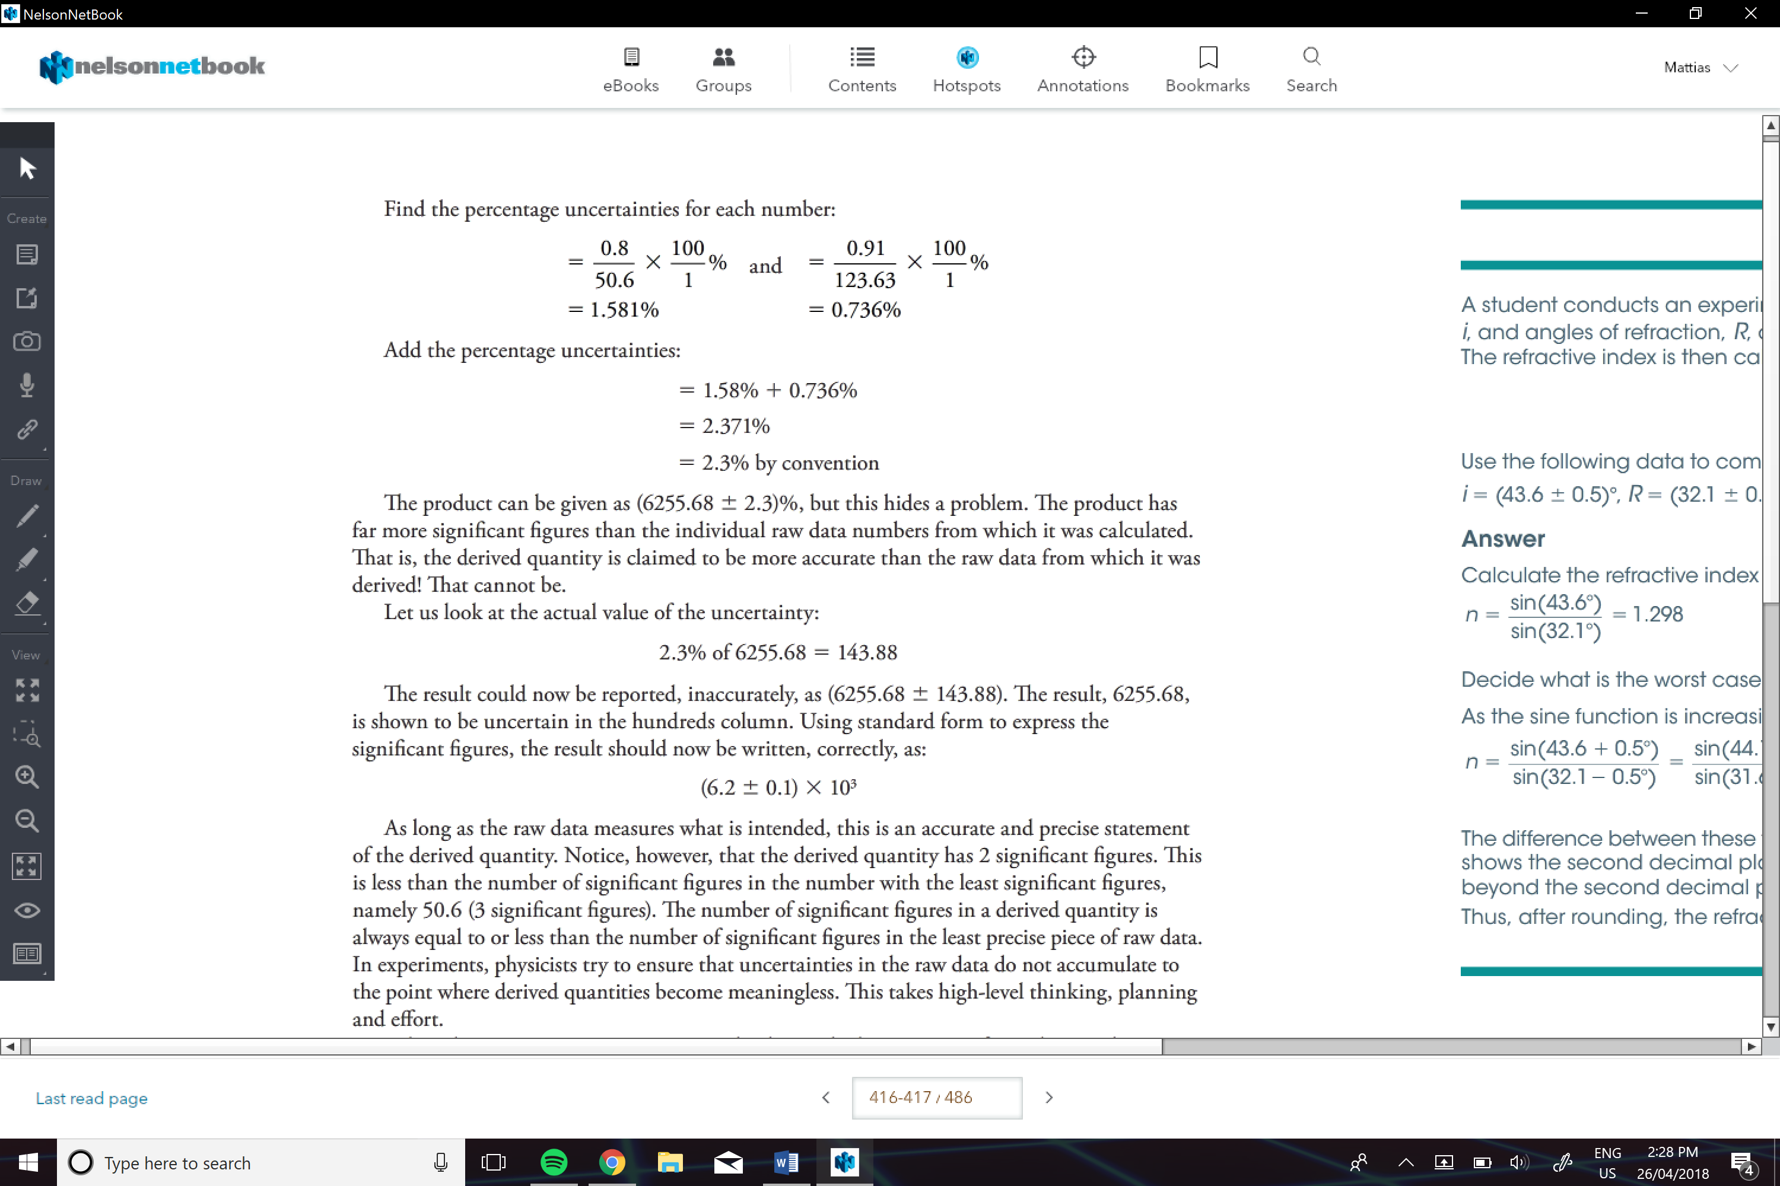e.g.